 | Supplier verification & Plant details |  |  |  | Verify Check  Verify Check  WARNING SIGNS (in cabin)  SEAT BELTS MUST BE WORN  Verify Check  Verify Check  ENVIRONMENTAL  Clean, free of weeds prior to arrival  WARNING DEVICES  Horn  Amber flashing beacon  Reversing alarm  DANGER – BEWARE OVERHEAD WIRES & UNDERGROUND SERVICES  Seat Belts Must Be Worn  Verify Check CAB  Verify Check  Exhaust  Verify Check  Engine guarding
  Cleanliness
  Seat condition OK
  Operator restraint provided
  Instruments operational & labelled
  Levers / controls operational
  Pedals in good condition
  ROPS to AS 2294
  Windows / wipers / washers
  Rear view mirrors
  Operator instruction (available on plant)
  Log Book
  Fire extinguisher with current tag
Verify Check  Pivots  Connecting rods  Safety pins  (no excessive wear) | Plant owner:
 | Address:
 | City/Suburb:
Hydraulics  Verify Check  Rams  Hoses  Connections  (check for excessive wear,  leaks and creep)  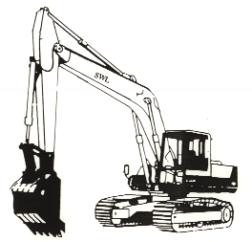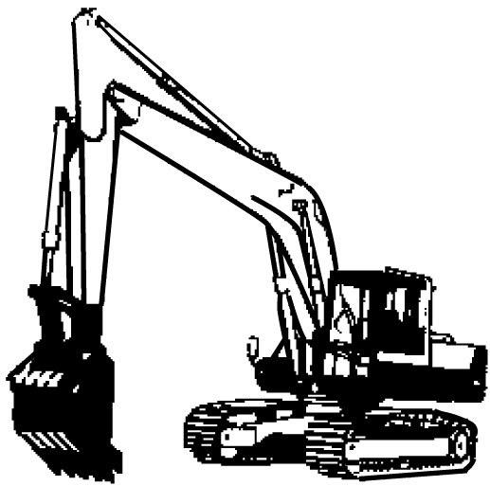 | Phone:
 | Plant make:
 | Plant model:
 | Serial no.:
Verify Check  SWL / Crane chart | Signature:
 | Date:
Verify Check  Quick hitch  Safety pins  (where applicable)  (If quick hitch is fitted  “NO LIFTING POINTS  ALLOWED” on back of  bucket) | Work Cover Certification - LE
 Plant to conform to manufacturer’s specifications and Plant Regulations.
 Plant operator is to provide daily checksheets to WDA on a weekly basis.
 Where applicable, Personal Protective Equipment must be worn.
 Plant Log Book detailing service history in accordance with Manufacturer’s specifications should be written legibly in English.
 Contractor must produce proof of competence of operator, e.g., Certificate of Competence, Licence, detailed Log Book
Hydraulics  Verify Check  Rams  Hoses  Connections  (check for excessive wear,  leaks and creep)  Verify Check  Tracks complete  Idlers adjusted  Drivers free from leaks  Tracks | WDA use only
Verify Check  Handrails  Steps | Note: Sign only when all items have been checked
 | Plant check by:
Instructions:  Verify Box to be ticked by Owner / Supplier / Operator prior to arrival onsite.  Check Box to be ticked after visual inspection by WDA | Position:
 | Date: |  | / /

